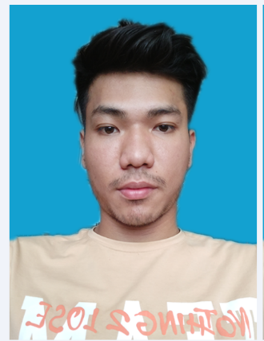

Name: Aung Thant Zin Myo

Address: Mandalay, 80th street, 9x10th street

Current City: Yangon

Email: [redminote5.app@gmail.com](mailto:redminote5.app@gmail.com)

Phone: 09750715559, 09958327584

**Career Objective**

Challenging and responsible position which would effectively utilize my prior experience, knowledge and abilities, self-confidence, team spirit, self-motivation and proficiency of technologies as a team player in web development.

**Personal Particulars**

Date of Birth: 11.7.1999

Gender: Male

Marital Status: Single

Nationality: Myanmar

Race: Burma

Religion: Buddhist

NRC No: 9/MaTaYa(N) 208654

**Position Finding: Junior Web Developer, OnJob Training**

**Expected Salary: Suitable**

**Technical Skills**

**Programming Languages**

HTML5,CSS3, Bootstrap5, JavaScript, JQuery, PHP, Laravel,MySQL.

**Operating Systems**

Window7, Window10, Ubuntu.

**Others**

Microsoft Word, Microsoft Excel, Microsoft PowerPoint, Adobe Photoshop, Git and Github.

**Educational Background**

**Degree Obtained Year**

University of Computer Studies Monywa(Final Year) 2020

Certification of PHP Web Developer Bootcamp(Myanmar IT Consulting) 2020

Communication Skills

Language Spoken Written

English Basic Basic

**Project Experiences**

1.Computer History(University Project)

2.Strand Gallery Shop(HTML, CSS, Bootstrap, JavaScript)

3.Shoplus Ecommerce Website(HTML, CSS, Bootstrap, JavaScript, JQuery, Pure PHP, MySQL Database)

4.LiquourShop Ecommerce Website(HTML, CSS, Bootstrap, JavaScript, JQuery, PHP with Laravel Framework MySQL Database)

**Personality**

Good interpersonal skills with adaptability and flexibility. Ability to work independently with minimum supervision. Ability to work well as part of a team.

**Interests**

Listening, Travelling, Writing and Designing Program, Studying IT Technology, Troubleshooting Problem.